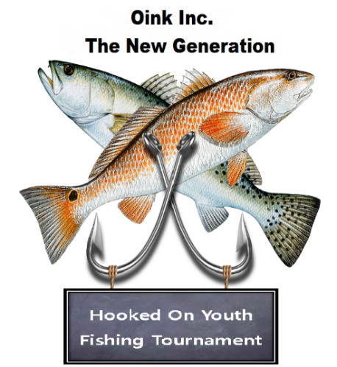

26th Annual

26th Annual

**Newsletter**

The 26th annual Hooked on Youth Fishing Tournament will be in Fulton, Texas at the **Paws & Taws Convention Center on July 25th & 26th, 2025**.

Registration will be taken in advance or on Friday, July 25, 2025 from 5:00 pm until 8:00 pm. The Captain’s Meeting will begin promptly at 8:30 pm.

This is a bay tournament with categories in Red Fish, Trout, Flounder, Black Drum, and Total Stringer Weight. The entry is $400.00 per boat, Guided and Unguided. If you opt for a guided boat, the guide fee is in addition to the entry fee.

Come out and have some FUN and maybe catch a fish or two.

The gun raffle has been such a success that we are having another 10-gun raffle at the tournament. Raffle tickets are **$20** each and we are only selling a limited amount. If you would like to purchase tickets in advance, please contact us through our website or email and someone will contact you.

We look forward to seeing each of you again and our newest members for the 1st time. For more information on the tournament or raffle, please contact Jennifer Burkholder at (210) 218-1406 or email us at **oinkincnewgeneration@yahoo.com**.

**More information may be found on our website:** [**www.oinkincnewgeneration.com**](http://www.oinkincnewgeneration.com)**.**

See You There,

Matt Burkholder, Chairman